TEMPLATE TO ILLUSTRATE THE MANUSCRIPT FORMAT
(ENTER TITLE IN ENGLISH HERE)

FOR MANUSCRIPTS SUBMITTED IN FRENCH, ENTER THE FRENCH TITLE HERE, OTHERWISE DELETE

Taro YAMADA(*), Jiro KAWAKAMI(**), Saburo YAMAKAWA(*)
(*) Organization, Postal address, City, Zip code, Country
E-mail address
(**)JSRAE, Nihonbashi-Otomi Bldg. 5F, 13-7, Nihon-bashi Odenma-cho, Chuo-ku, Tokyo, 103-0011 Japan
icr2015@ics-inc.co.jp

ABSTRACT
Authors are requested to prepare their papers exactly in accordance with the instructions given below. The abstract should contain at most 150 words in the language of the manuscript. For manuscripts submitted in French, the title and the abstract should be in both French and English. The entire manuscript (abstract, text, figures, tables and references) should not exceed 8 pages, or 12 pages for keynote lectures. The manuscript should be submitted via the congress Web site http://www.icr2015.org in Microsoft Word format (.docx) and Adobe Portable Document Format (.pdf).

For manuscripts submitted in French, please enter the French abstract here.
- INTRODUCTION
The manuscripts should report on original research or on technical developments and their applications. They should contain quality scientific or technical information. Manuscripts of a commercial nature will be rejected and will not be authorized for presentation. The process of validation and acceptance and/or rejection of papers shall be under the authority of a Programme Committee, which will not be held responsible for any errors appearing in the final text. Authors assume sole responsibility for their manuscript, both for its form and its substance, and are invited to check their manuscripts thoroughly before submittal.

Manuscripts should be written in one of the two official languages of the IIR, i.e. English or French. The terminology of the IIR’s International Dictionary of Refrigeration should be used as much as possible.
- AUTHORS
The author’s first name (given name) should be given first, followed by the last name (family name). A corresponding author's complete mailing address including the e-mail address should be given, including his/her company or organization. The address and affiliation of other authors may be mentioned, if judged necessary. Asterisks should be used to indicate which address goes with which author. The address(es) should be centred and in lower-case letters. The different parts of the address(es) should be separated by commas and if more than one line is necessary, the various lines should be of roughly the same length.
- FORMAT AND MARGINS
Set the paper size A4 (width 210 mm, height 297 mm). All text of the manuscript must be located within a 170 mm by 252 mm rectangle of an A4 page. The margins are given in Table 1. An example of the page format is given in Figure 1.

Manuscript title: Times New Roman, 14 points, centred, boldface type, written in capital letters. Add the blank space 18-point after the title, do not leave blank lines (Use: Format → Article/Paragraph → Indentations → Spaces).

Text: Times New Roman, 11-points, single spaced, justified block.
Table 1. Page margins of manuscripts. Enter one blank line below each Table.
Margin  Position | Top | Bottom | Left | Right
Margin size  (mm) | 20 | 25 | 20 | 20

Header and footer: Authors are asked to add a one-line left-justified header and footer on each page of the manuscript. The header and the footer shall be placed 12.7 mm from the bottom edge of the page. Leave the header and the footer – the editors will insert the paper ID and sequential pagination there.

Do not use page numbering. Do not use footnotes. Turn off the “track changes” function.
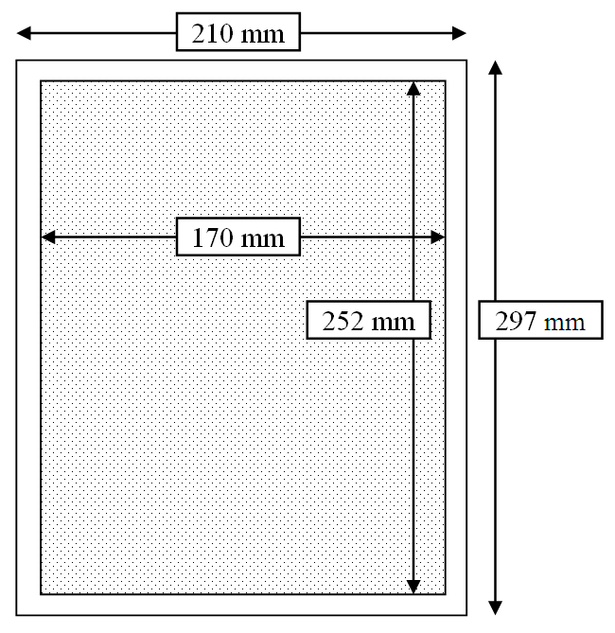
Figure 1. Text area of manuscripts. Enter one blank line above each Figure.
- HEADINGS
Titles of all sections should be 12-points, centred, and in boldface capital letters. Blank space 12-points should be placed above and below the titles.
  - Sub-Section Headings
Sub-section headings should be in lower-case beginning with a capital letter of each word, 11-point, bold letters and justified left. Blank space 12-point should be placed above, but not below.
    - Sub-sub-section headings
Sub-sub-sections should be avoided. If used, sub-section headings should be in lower-casebeginning with a capital letter of the first word, 11-point, regular letters and justified left. Blank space 12-point should be placed above, but not below.
- TABLES AND FIGURES
Each table should be numbered (Tables 1, 2, 3, etc.), with the caption being placed above the table. Each figure should be numbered (Figures 1, 2, 3, etc.), with the caption being placed below the figure. All tables and figures should be numbered sequentially. Figures and tables should be incorporated in the text and should not run into the margins. Fonts used in figures should be large enough to be legible. Black and white colours are preferred.
- EQUATIONS
Equations should be aligned left, numbered in order (i.e. (1), (2), (3), etc.) down the right-hand side of the page and cited in the text with its number, e.g. eq. (1). Equations should be separated from the text above and below by a blank space 12-points. If necessary, a symbol-nomenclature glossary should be placed at the end of the manuscript.
c = a + b (1)
where
a = apples [unit], b = bananas [unit], c = fruit salad [kg]
- UNITS
The SI system of units should be used.
- FILE SIZE
Occasionally, Microsoft Word may generate larger-than-necessary .pdf files when images inserted into the document are manipulated in Microsoft Word. To minimize this issue, use an image editing tool to resize the images to the appropriate printing resolution (usually 300 dpi), and then insert the image into Microsoft Word using Insert | Picture | From File...

Reduce the size / pixel resolution of images in the manuscript so that the file size does not exceed 3 MB.
- DISCUSSION
It is important that you write for a general audience. It is also important that your work is presented in a professional fashion. This guideline is intended to help you achieve that goal.

Remember the following:
- Do not wait until the last minute to submit your paper.
- Do not expect to get an extension for submitting your paper.
- If you do not submit your paper according to the guidelines specified in these instructions, there is no guarantee that your paper will be included in the congress proceedings.
- CONCLUSIONS
More information can be found in the “Guidelines for Preparation of Manuscripts” which is presented on the congress Web site: http://www.icr2015.org.
- REFERENCES
Green L, Lundholl P. 1997, CFC and HCFC refrigerants retrofits, Int. J. Refrig. 20(1): 49-54.
Forbes Pearson S. 1996, Uses of Hydrocarbon Refrigerants, Proc. Aarhus Conference, IIF/IIR: 439-446.
Janna SW. 1986, Engineering Heat Transfer, PWS Publishers, Boston, 769 p.
Duminil M. 1995, Principes de la production du froid, In: Côme D, Ulrich. R. La chaîne du froid – Le froid au service de l'homme, Hermann, Paris: 33-144.

NOTE:
Within the text of a manuscript, bibliographical sources should be cited by giving the last name(s) of the author(s) and the year of publication. The year should always be in parentheses, whether or not the name of the author(s) is.
The two possibilities are illustrated as follows:
Albert (1957) showed that the blend was azeotropic.
or: It was shown that the blend was azeotropic (Albert, 1957).

When there are two authors, the names of both should be cited, e.g.:
Albert and Klaus (1981) observed that the blend was azeotropic.
or: It was observed recently that the blend was azeotropic (Albert and Klaus, 1981).

When there are three or more authors, only the lead author of the source should be cited. The names of the other authors should be designated by et al. in italics, e.g.:
Lee et al. (1982) developed a new blend.
or: A new blend was developed (Lee et al., 1982).

When the same author and the same year of publication are cited from more than one source, the sources should be distinguished in the text by adding the lower-case letter "a" to the year of publication of the first source cited, "b" for the second source, and so on, as shown hereafter:
Klaus (1980a) discovered...
and further on in the text:
Klaus also pointed out (1980b) that...

The sources cited in the text should be listed in order at the end of the manuscript.
Sources should be in alphabetical order of the author's name or of the lead author if there are several authors.
They should be numbered 1., 2., etc. so that the number of sources will be readily apparent. The sources should be presented as follows:

1 - Article from a periodical
Name(s) of the author(s), first name initial(s), year of publication, title of article, title of periodical in italics and abbreviated according to international standards, volume number, issue number (between brackets), first and last page.
e.g. Herbe L, Lundqvist P. 1997, CFC and HCFC refrigerants retrofits, Int. J. Refrig. 20(1): 49-54.

2 - Paper published in conference proceedings
Name(s) of the author(s), first name initial(s), year of publication, title of article, title of the conference in italics, publisher of proceedings: first and last page.
e.g. Forbes Pearson S. 1996, Uses of Hydrocarbon Refrigerants, Proc. Aarhus Conference, IIF/IIR: 439-446.

3 - Book
Name(s) of the author(s), first name initial(s), year of publication, title of the book in italics, name of publisher,
place of publication, number of pages. Establishments can be considered authors when they assume main responsibility for the text and their publications reflect their collective reflections or activities.
e.g. Janna SW. 1986, Engineering Heat Transfer, PWS Publishers, Boston, 769 p.
4 - Book chapter
Name(s) of the author(s), first name initial(s), year of publication, title of chapter, In: name(s) and initial(s) of the co-ordinator(s), title of the book in italics, name of publisher, place of publication, first and last page.
e.g. Duminil M. 1995, Principes de la production du froid, In: Côme D, Ulrich. R. La chaîne du froid – Le froid au service de l'homme, Hermann, Paris: 33-144.

